

NAME – Rahul Maurya

UID – 20BCS7260 BRANCH – CSE

SEC- 716B SUBJECT- SE LAB DATE – 27-04-2022

Exp 3.3(Q2)

The Food Order System Data Flow Diagram example contains three processes, four external entities, and two data stores.

Based on the diagram, we know that a customer can place an Order. The Order Food process receives the Order, forwards it to the Kitchen, store it in the Order data store, and store the updated Inventory details in the Inventory data store. The process also delivers a Bill to the Customer.

The Manager can receive Reports through the Generate Reports process, which takes Inventory details and Orders as input from the Inventory and Order data store respectively.

The Manager can also initiate the Order Inventory process by providing Inventory order. The process forwards the Inventory order to the Supplier and stores the updated Inventory details in the Inventory data store.

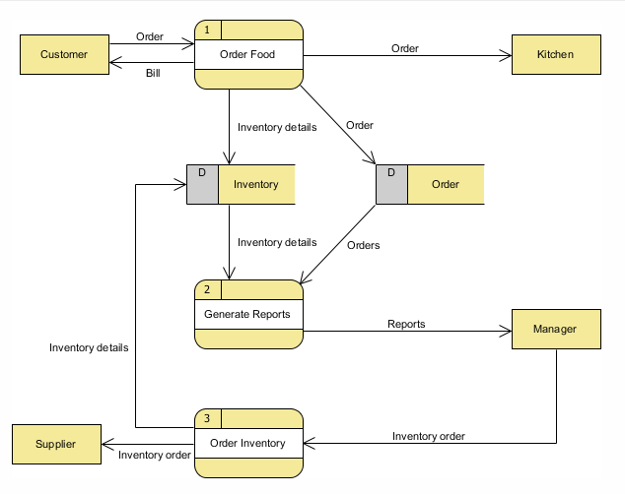

DFD LEVEL 1